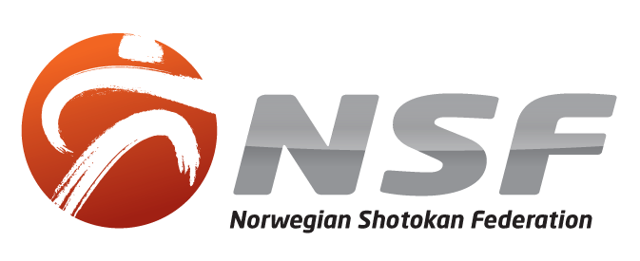
SUMMER CAMP 2023
Fredrikstad 29/6 - 02/7
- Richard Amos - 8. dan
- Aidan Trimble - 8. dan
- Matt Price - 7. dan
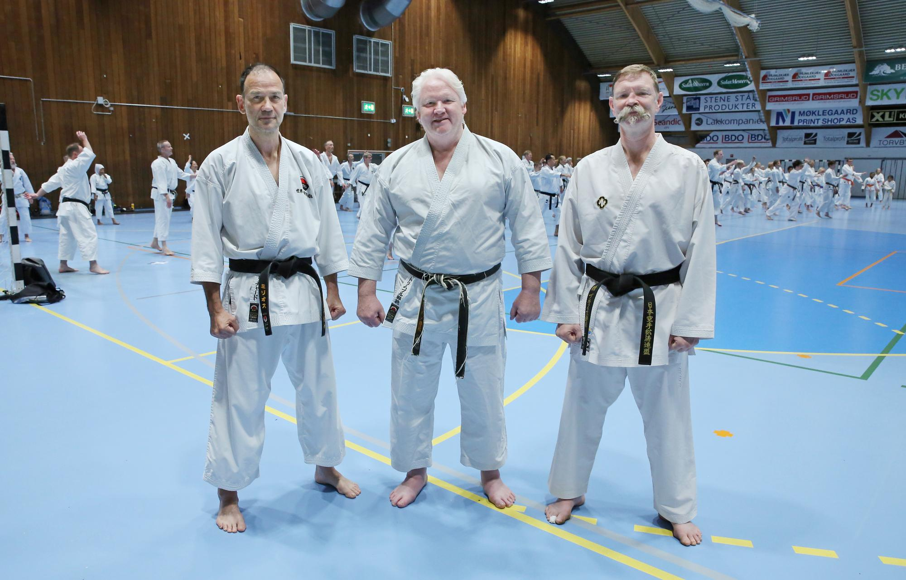
Foto: Sylve Holmgren
WELCOME!
Welcome to the city of Fredrikstad and the old fortress town, (the fort was originally built to deter the Swedes).
We aim to provide a friendly and social setting for a first class training event!

THE SERVICE DESK
is located to the left of the main entrance of the training facility.
This is where you register before the first training.
You can also buy camp passes/pay for your grading at an additional fee of 200 NOK.
Some heavy weight and light weight (kumite) NFS dogis (karate uniforms) are also available for sale.
And of course, we are there to answer any questions you may have.
SCHEDULE
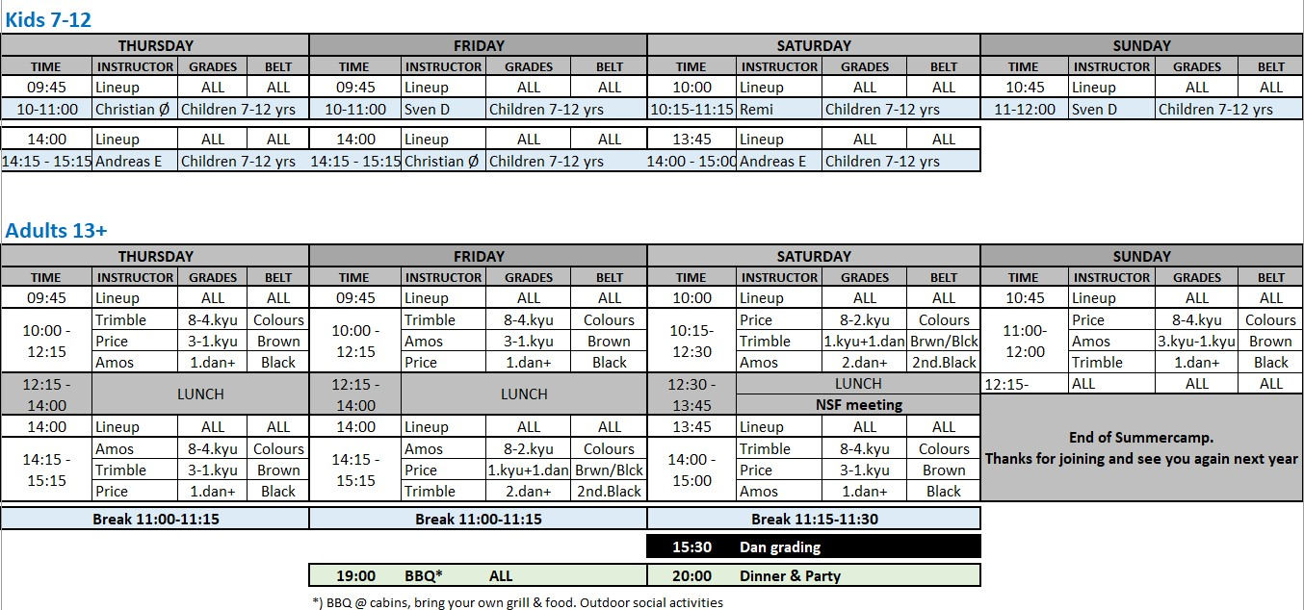
Please help keeping the training facility tidy. Toss garbage in the bins. Respect normal Dojo etiquette.
FRIDAY NIGHT BBQ – 1900 HRS.
The BBQ will be held by the cabins. Bring your own food, drinks and grills.
And, as usual, which one is the most flexible karateka of the summer camp will be decided during the annual limbo competition (by the play ground).
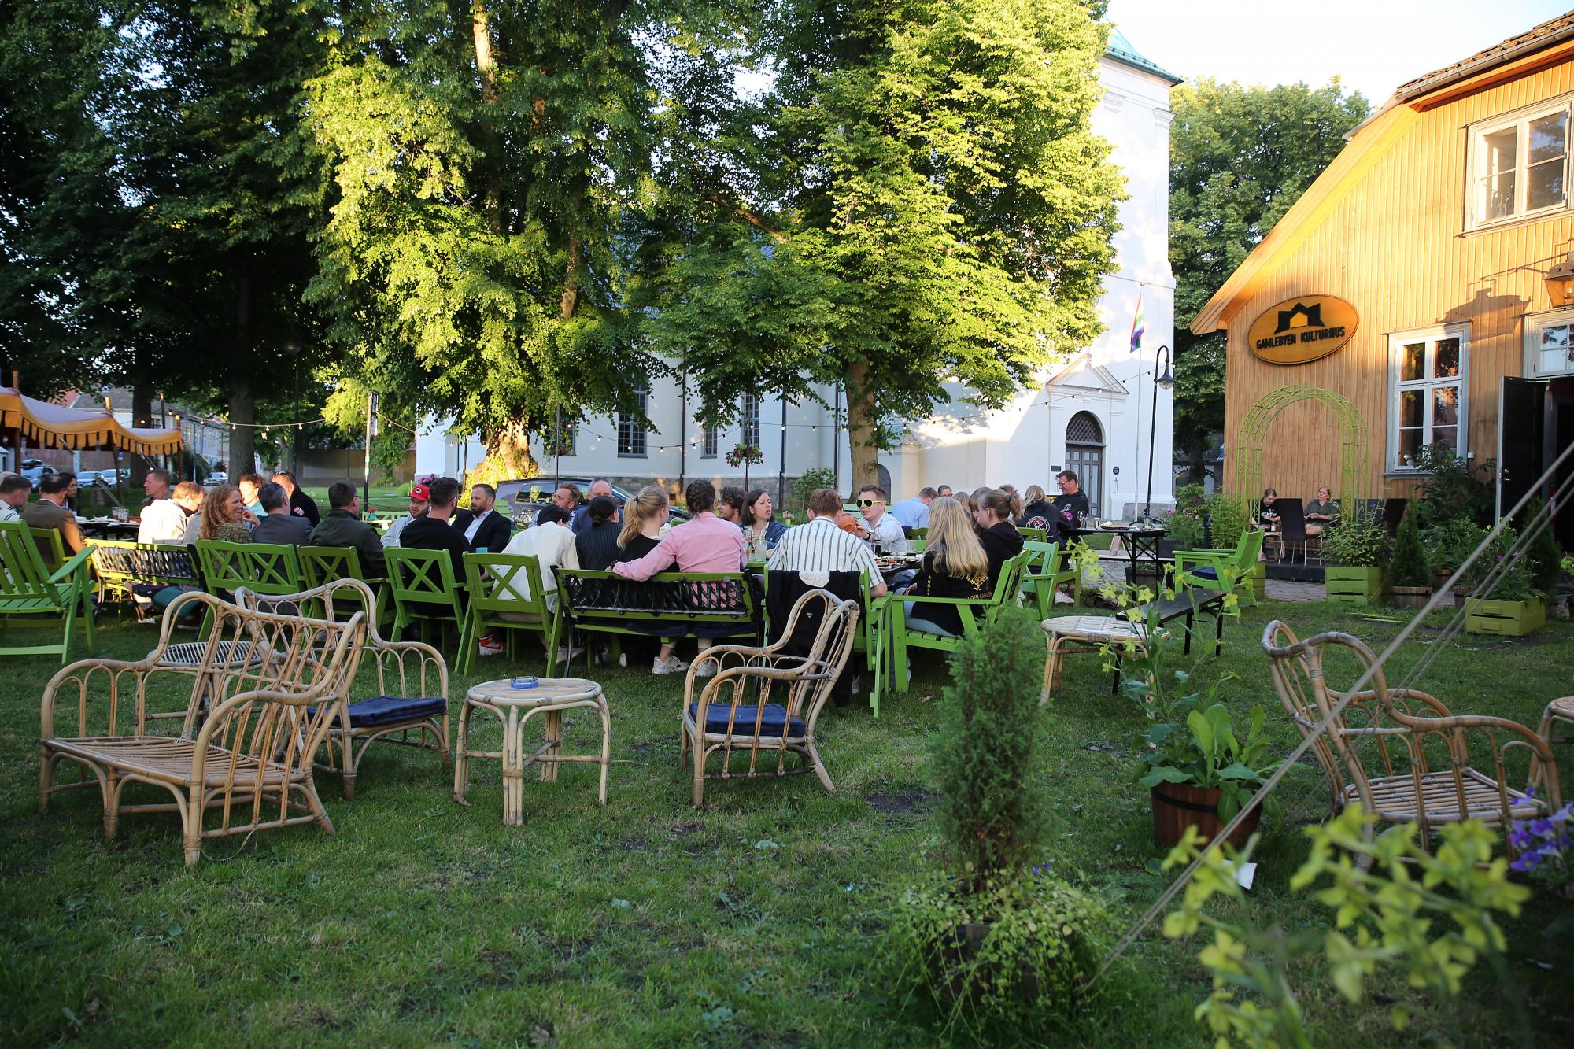
CAMP PARTY – SATURDAY 2000 HRS.
The dinner/party will be held at Gamlebyen Kulturhus,
Kirkegaten 24, 1632 Gamle Fredrikstad.
Tickets cost 300 NOK, which covers food and entry.
To make it easier for us to plan this event, please sign up/pay in advance:
https://www.deltager.no/event/nsf_summercamp_2023_29062023#init Foto: Sylve Holmgren
If you sign up whilst on the summer camp, you can either pay by Zettle (card) or by Vipps.
Cash is not an option.
Food: Chicken wok.
Dress code: Up to yourself.
Note that you because NSF is renting the location, you cannot show up not attending the dinner (there will be access control).
Alcohol brought in to the restaurant is of course not allowed. If you are under 18 years old and under the influence, you will not be admitted to the premises. Any behavior that reflects badly on NSF might have consequences on future participation at the summer camp.
GETTING AROUND
It takes 5-10 minutes to walk from the training facility and the motel to the ferry. During daytime the ferry crosses continuously. Otherwise every 15 minutes. Fredrikstad city center is about 20-30 minutes walking distance away. Most necessities can be purchased in stores in Gamlebyen. There are restaurants, bars, etc. there as well.
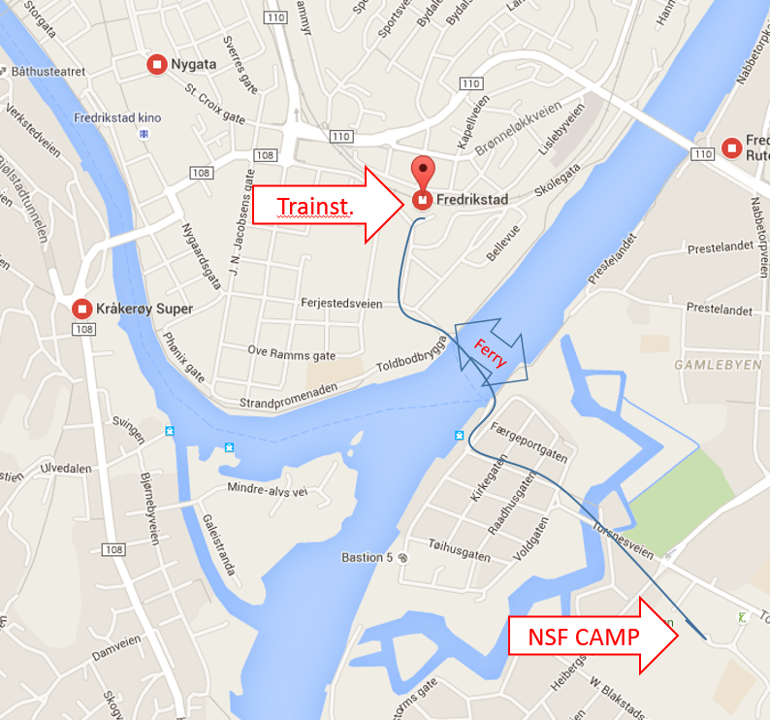

FOREIGN PERSONS CULTURAL GUIDE TO NORWEGIANS
Norwegians are generally friendlier than they appear. To speak in monosyllables is common in Norway. The English language has three times as many words as Norwegian. We might come across as a bit direct. We do

not mean to be rude, but normally we say what we think. The further north you travel in Norway the more people tend to be direct (swearing is not uncommon, but nobody gets offended by it), but also more friendly. Please keep this in mind and be patient with us. Sorry that everything is so expensive here..
USEFUL LINKS
Buses to and from Gardermoen:
https://www.flybussen.no/en/airports/oslo-airport/oslo-airport/
Train Oslo - Fredrikstad (R20):
https://www.vy.no/tog/oslo-fredrikstad
Taxi: Call 02393 or 02600
FEEDBACK
Please forward any feedback on things we can improve for next year to:
norwegianshotokanfederation@gmail.com
Bullet points with improve/sustain will be appreciated.
We are continuously looking to develop our summer camp.
Trond Erik Steine
On behalf of NSF

